Experiment No. 09

Name:- Iqra Shaikh

Roll no:- 24DCO06

Batch :- 01

AIM :Mesh Topology in Cisco Packet Tracer with IP Configuration

What is Mesh Topology?
Mesh topology is a network design where every device is directly connected to all other devices. This creates multiple communication paths between devices, making the network highly reliable and fault-tolerant.

Advantages
- High Reliability – Network continues to function even if one link fails.
- Fast Communication – Direct links allow simultaneous data transfers.
- Secure – Dedicated paths reduce the chances of unauthorized access.

Disadvantages
- Expensive – Requires a large number of cables and ports.
- Complex Setup – Becomes difficult to configure and manage with more devices.
- Not Easily Scalable – Number of connections increases rapidly as devices increase

Steps to Install Cisco Packet Tracer
- Visit the Cisco NetAcad website.
- Create or log in to your account.
- Download Cisco Packet Tracer for your operating system.
- Install and launch the software.
Steps to Implement Mesh Topology with IP Configuration
- Open Cisco Packet Tracer.
- Drag and place PCs or Routers (Example: PC1, PC2, PC3, PC4).
- Connect each device to every other device using Copper Cross-Over cables:
  - PC1 to PC2
  - PC1 to PC3
  - PC1 to PC4
  - PC2 to PC3
  - PC2 to PC4
  - PC3 to PC4
- Assign the following IP addresses:
  - PC1 → 192.168.1.1
  - PC2 → 192.168.1.2
  - PC3 → 192.168.1.3
  - PC4 → 192.168.1.4
- Go to PC → Desktop → IP Configuration and enter the respective IP.
- Open Command Prompt on each PC and test connectivity using the Ping command.
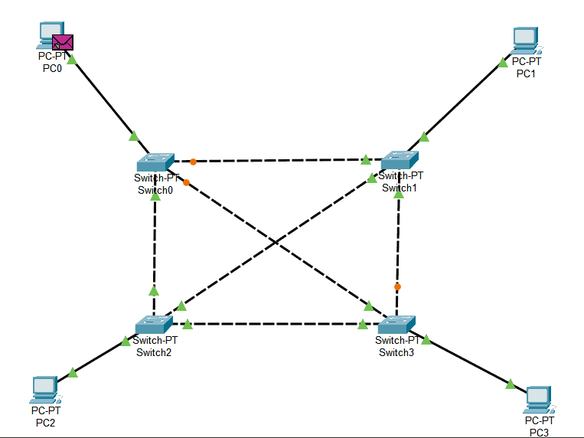

Conclusion
Mesh topology provides excellent reliability and performance due to its multiple redundant paths. Although it requires more cost and effort to set up, it is ideal for critical networks where continuous communication is essential. Cisco Packet Tracer helps in visualizing and understanding this topology effectively.

